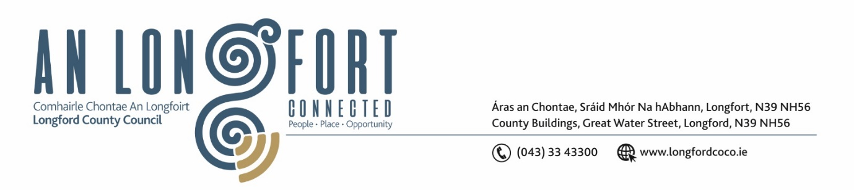

***Please note meeting will be held in GRANARD LIBRARY***

8 Nollaig 2022.

**Chuig: Gach Ball don Chomhairle.**

A Chomhairleoir,

Iarrtar ort bheith i láthair ag Cruinniú Míosuil Chomhairle Chontae Longfoirt a tionólfar I leabharlann Ghránard, Ghránard, are an **Chéadaoin 14ú Nollaig 2022 ag** **4pm** chun gnó a dhéanamh d’réir an Chláir thíos.

You are requested to attend the Monthly Meeting of Longford County Council to be held in Granard Library, Granard on **Wednesday 14 December 2022 at 4pm** to transact business, as set out on the Agenda hereunder.

Mise le meas,

*Ann Marie Mc Keon*

**__________________**

**Ann Marie Mc Keon**

**Meetings Administrator.**

**C L Á R**

Prayer before meeting.

**1.** Confirmation of Minutes

1. Monthly Meeting of Longford County Council held on 9 November 2022– copy enclosed.
2. Minutes of Committee Meeting of Longford County Council held on 24 October 2022 – copy enclosed.
3. Minutes of Finance Committee Meeting of Longford County Council held 14 November 2022 – copy enclosed
4. Minutes of Budget Meeting of Longford County Council on 21 November 2022 – copy enclosed
5. Minutes of Adjourned Budget Meeting of Longford County Council on 25 November 2022 – copy enclosed

**2.** Matters Arising.

**3.** Declaration of Interest by Members.

**4.** To note Management Report – enclosed.

**5.** To note adopted Minutes of Corporate Policy Group Meeting held on the

11 October 2022 – enclosed.

**7. Finance and IT**

1. NOAC Local Authority Performance Indicator Report 2021 - enclosed.

**8. Community, Corporate and Enterprise**

**(a)** Item referred from Protocols and Procedure Committee meeting held on 12 October 2022 and Placemaking Strategic Policy Committee meeting held on 17 October 2022:

Consideration of draft Commemorative Plaques and Monuments Policy - enclosed.

**(b)** Item referred from Protocols and Procedure Committee meeting held on 12 October 2022:

Consideration of Terms of Reference for Protocols and Procedure Committee – enclosed.

**(c)** Item referred from Protocols and Procedure Committee meeting held on 12 October

2022:

Consideration of Terms of Reference for Place Naming Committee – enclosed.

**(d)** Item referred from Placemaking Strategic Policy Committee meeting held on 17 October 2022:

Consideration of draft Twinning Policy – enclosed.

**(e)** Item referred from the Protocols and Procedure Committee meeting held on 12 October 2022:

Consideration of amendments to Civic Protocols (updated October 2022) – enclosed.

**(f)** Protocol for dealing with Complaints made against Elected Members of Longford

County Council – enclosed.

**(g)** Chief Executive Annual Progress Report on Implementation of the Corporate Plan.

**(h)** Political Donations - Local Elections (Disclosure of Donations and Expenditure) Act 1999, as amended - Members of Local Authorities.

**(Departmental Guidelines and forms for completion will be circulated)**

**(i)** Political Donations - Local Elections (Disclosure of Donation and Expenditure) Act 1999, as amended - Third Parties.

**(Departmental Guidelines and forms for completion will be circulated)**

**(j)** Date of January 2023 County Council meeting – 18 January 2023.

**(k)** Notice of Motions, submitted by Councillors, as listed hereunder –

**Councillor Uruemu Adejinmi**

Calling on Longford County Council to seek funding from the Department of Disability to provide inclusive playground equipment in all recreational areas so that children of all ages and abilities can enjoy playing together.

**Councillor Mark Casey**

Following my proposal that was seconded at the budget meeting that Longford County Council use the €55k euro that was allocated for new playgrounds in the budget to provide a new playground in Ardagh.

**9. Planning and Project Delivery**

**(a)** To note Planning Applications received since last meeting of the Council.

**(b)** Consideration of Part VIII No 98 - Rose Cottage, Ballinalee, County Longford. Report

in accordance with Section 179 of the Planning and Development Act 2000 (as amended) and Part 8 of the Planning & Development Regulations 2001 (as amended) – enclosed

**(c)** Notice of Motions, submitted by Councillors, as listed hereunder –

**Councillor Gerry Warnock**

I am calling on the Executive of Longford County Council to immediately withdraw its consent for the OPW to consider the former Longford Greyhound Stadium site as a potential location for modular housing. The site is an inappropriate location given the existing proliferation of housing in the south of Longford Town. The site was historically bequeathed to the "People of Longford for the enjoyment of the People of Longford" as a recreational amenity and we have protected it as such in every Town & County Development Plan. The site was never intended for housing of any kind and is a key Regeneration Site here in Longford Town and must be safeguarded for future generations to utilise as a recreational or sporting amenity. We have already suggested a suitable location for temporary accommodation within the Connolly Barrack complex by way of investing in the Barracks Building for apartment type accommodation to help with the humanitarian efforts.

**10. General**

**(a)** Notice of Motions, submitted by Councillors, as listed hereunder –

**Councillor Peggy Nolan**

I am requesting that this Council engage with the HSE and demand the provision of at least four palliative care beds in Longford Town. The fact that fourteen such beds are being placed in Tullamore to serve the needs of Longford is totally unacceptable as there is no transport links to Tullamore.

**11.**  **Correspondence**

1. Correspondence dated 14 November 2022 received from the Minister for Housing, Local Government and Heritage - Re Notice of Motion from Councillor Paul Ross on social housing income limits – enclosed.
2. Correspondence dated 30 November 2022 received from the Minister for Agriculture, Food and the Marine – Re Notice of Motion from Councillor Pauric Brady on the extension of the closing date for ACRES measure – enclosed.
3. Correspondence – Extension of Tenure Period of Chief Executive

**12. Training – enclosed.**

**13. Votes of Sympathy**